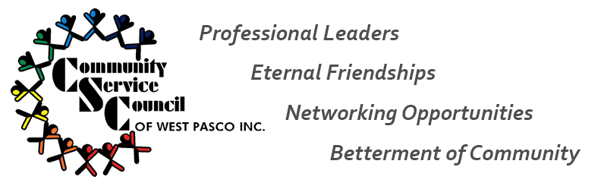
2021 Senior Yard Spruce Up – Saturday, April 17, 2021
It’s that time of year again where we reach out to a Senior citizen who needs some help with the exterior of their home. So, if you know someone who could benefit from CSC’s helping hands in the form of general landscaping and yard clean up, complete and submit an application!
APPLICATIONS
Blank applications are now available at: http://www.communityservicecouncil.org/
-or- request via email: BBennett@PascoKidsFirst.org

Completed applications may be submitted via:
Email: BBennett@PascoKidsFirst.org
US Mail: Pasco Kids First, Attn: Becky Bennett, 7344 Little Road, New Port Richey, FL 34654
Fax: (727) 727-848-1292 (Attn: Becky Bennett)
Application deadline: Friday, March 19th at 5pm
CRITERIA
Applicant Criteria:
- Must be 65 or older
- Must be a West Pasco resident
- Home chosen must be Senior’s primary residence
All applications will be reviewed by the Senior Yard Spruce Up committee members to determine a winner. The committee will review each application for need based on the information provided. Three applications will be selected for review. The committee members will contact and visit each senior home to verify need and assess the exterior of the home for possibilities. The committee will then select one winner for exterior home spruce up!

