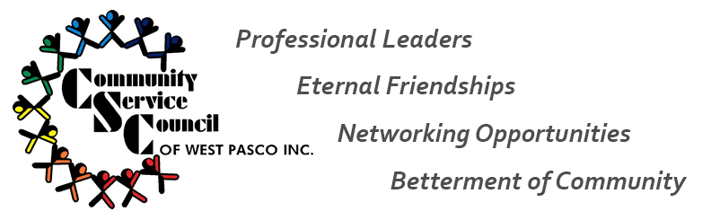
2021 Senior Yard Spruce Up Application– Saturday, April 17, 2021
Name: ____________________________________________________________
Address: ____________________________________________________________
Phone: ____________________________________________________________
Email: ____________________________________________________________
Birthdate: ______________________________________
Brief description of you should be selected as the recipient of an exterior home spruce up:
______________________________________________________________________________________________________________________________________________________________________________________________________________________________________________________________________________________________________________________________________________________________________________________________________________________________________________________________________________________________________________________________________________________________________________________________________________________________________________________________________________________________________________________________________________________________________________________________________________________________________________________________________________________________________________________________________________________________________________________________________________________________________________________________________________________________________________________
Brief description of desired results:
________________________________________________________________________________________________________________________________________________________________________________________________________________________________________________________________________________________________________________________________________________________________________________________________________
I agree to hold harmless Community Service Council of West Pasco, volunteer workers and all sponsors and donors of supplies or any liability due to damage or loss during this project. I am in no way responsible for any cost associated with this project. I understand the services and supplies are being donated. I will accept the services provided during this one day project as a final result and cannot expect any follow up maintenance or service. By signing this application, I agree to all contest rules and meet the necessary guidelines.
_________________________________ ____________________
Contest Applicant Date

