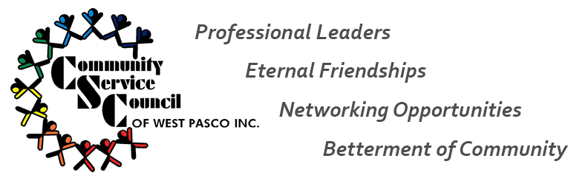
2017 Senior Spruce Up – Saturday, April 29, 2017
It’s that time of year again where we reach out to a Senior citizen who needs some help with the exterior of their home. So, if you know someone who could benefit from CSC’s helping hands in the form of general landscaping and yard clean up, complete and submit an application!
APPLICATIONS
Blank applications are now available at: http://www.communityservicecouncil.org/
-or- request via email: JodyA@DisabilityAchievementCenter.org

Completed applications may be submitted via:
Email: JodyA@DisabilityAchievementCenter.org
US Mail: Disability Achievement Center, Attn: Jody Armstrong, 12552 Belcher Rd. S., Largo, FL 33773
Fax: (727) 539-7588 (Attn: Jody)
Application deadline: Monday, April 17th at 5pm
CRITERIA
Applicant Criteria:
- Must be 65 or older
- Must be a West Pasco resident
- Home chosen must be Senior’s primary residence
All applications will be reviewed by the Senior Yard Spruce Up committee members to determine a winner. The committee will review each application for need based on the information provided. Three applications will be selected for review. The committee members will contact and visit each senior home to verify need and assess the exterior of the home for possibilities. The committee will then select one winner for exterior home spruce up!

